Budget and Perkins Application Approval Meeting Minutes
Date: July 7th
Attendance via Zoom Meeting: Robin West, Michael Hehnke, Joe Huebbe, Cale Hutchings, Barb South, Rhys South, Cody Smith, Todd Vander Velde, Gene Olsen
- Presentation and discussion of 2020-2021 Budget
  - Perkins funding is down slightly
  - Iowa TSA had a reserve built up so we could be ok without state conference income.
  - Rhys shared the 2020-2021 Budget
  - Motion to Approve next year’s budget: Robin West; 2nd: Joe Huebbe
- Discussion on Perkins funding
  - Robin West asked Cale Hutching for clarification on Perkins funds that will be available for CTE programs.
  - Allowable Perking Expenses provided by Cale Hutchings per DOE website:
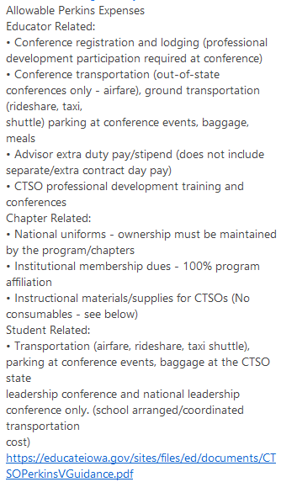
  - Alignment is for CTE programs that are authorized in those CTE programs.
  - Training and Guidance for TSA Advisors:
Gene Olsen brought up the need for videos to be presented for new Advisors as an introduction to the TSA events. He will look to the State Officers to help with these videos. Rhys has asked the television students at Johnston to also assist in these videos.
Robin West mentioned that it would be helpful for to create a calendar of activities for advisors. Cale Hutchings let us know that there will be an Advisor Academy (kick off in August and 2 x a month -meetings to help new or interested advisors for CTSO programs. Gene Olsen will plan to attend the August 6th Advisor Academy.

- National dues changes
  - Increase in all membership levels
    - Red and white are $12
    - Blue is now $400
  - Iowa dues: Rhys discussed and shared with the Advisors our current dues. The question was brought up: Do we want to change our dues?
    - Red is $10 per
    - White is $9
    - Blue is $150 (Gene suggested that we raise our Blue dues to $190)
      - Motioned by Rhys South to up the Blue Cap Membership to $190; Seconded by Joe Huebbe.
- Fall Leadership Conference
  - Location: Sun Stream, Ogden
  - Options: October 5th at Camp, possible online if needed.
- Board Election: The board will remain the same for this fall. The board will plan to meet during the ITEA meeting on September 21st in Knoxville.
- Pre-Conference Date: November 21st (location to be determined)
- Iowa Event Rules 2020-2021: Rhys will share the Google Drive: Iowa Event Rules with advisors

