FALL LEADERSHIP CONFERENCE

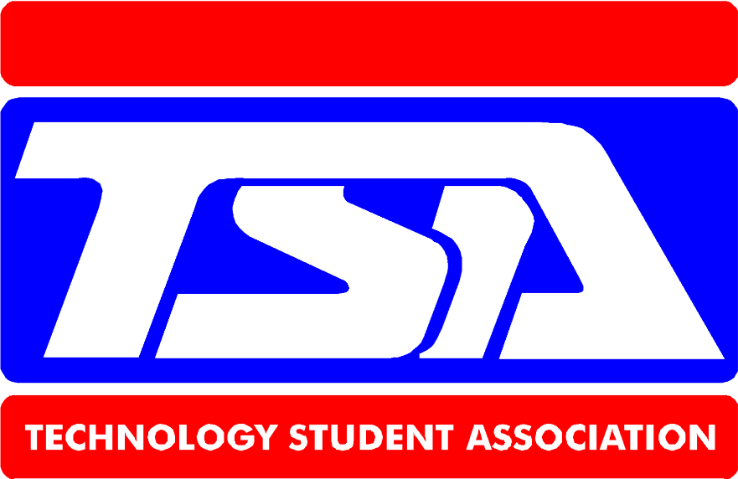

September 30, 2019
9:00-2:00
Ogden, IA
Planned Activities Cost = $20 per person
- Zip Line Lunch Provided
- Rock Wall www.iowatsa.org
- Leap Presentations for more information
- Ropes course

